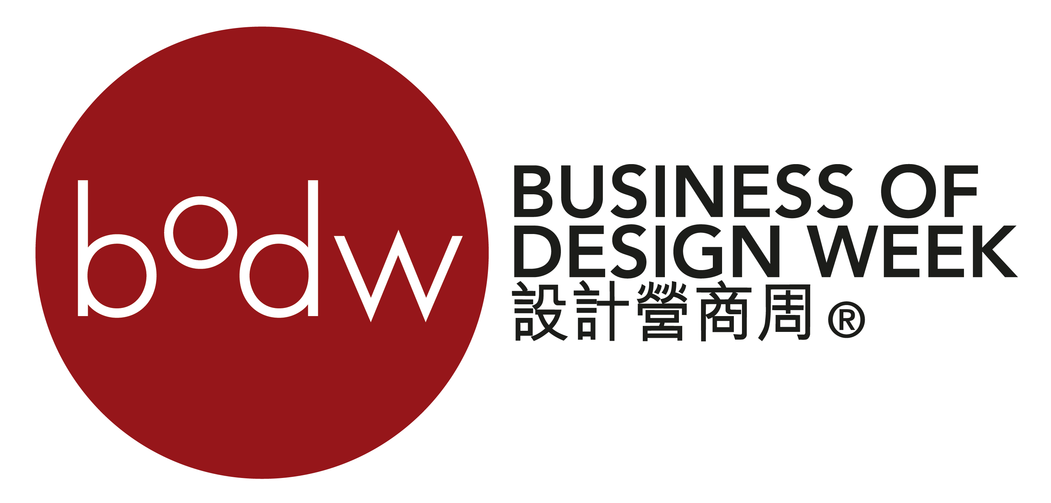

Each form should be used for one registration only. It can be photocopied, downloaded from www.bodw.com or obtained from the Conference Secretariat office. Registration is only valid upon receipt of the full registration fee.

Participant's Details
December 201
Title: Dr. Prof. Mr. Mrs. Ms.
First Name: |  | Last Name:
Job Title: |  | Company:
Company Address:
City: |  | Country:
E-mail: |  | Mobile :
Business Phone: | ( ) | Fax: | ( )

BODW Registration (1-6 December 2014)

I would like to purchase | Registration Category | Promotion Rate** (HK$)  On or before 1 Nov 2014 | Regular Rate (HK$)
 | Full Pass (7 sessions + *DesignEd Asia) | 5,500 | 8,000
 | 6 sessions Pass | 4,500 | 7,000
 | 1 session Pass (Half-Day Pass) | 900 | 1,400

Session Selection

Please tick your preferred session (one session per each AM/PM only)

Date | Sessions
1 Dec PM | Technology for Design
4 Dec AM | Plenary I - Living Design
4 Dec PM | Session 1 – Design for Sustainability or Session 2 - Product & Design or  Session 3 - Fashion & Design
5 Dec AM | Plenary II – Innovation / Smart City
5 Dec PM | Plenary III – Designing Business or Session 4 – Communication & Design or  Session 5 – Space & Design
6 Dec AM | Session 6 - Culture & the City (I) or Brand Asia (AM)
6 Dec PM | Session 6 - Culture & the City (II) or Brand Asia (PM)
*For updated information of the programme schedule, please visit http://www.bodw.com

*DesignEd Asia Conference : 2nd December 2014 – 3rd December 2014
Venue: Hong Kong Convention & Exhibition Centre
For more details, please visit: www.designedasia.com

BODW Gala Dinner - 5 December 2014 (Fri)

 | Price in HK$ | No. of pax(s) |  | Amount (HK$)
Dinner Fee (12 pax per table) | HK$1,500 per person
 |  |  | Total Amount:
Please indicate any special dietary requirements (if any) by ticking () the appropriate box(s): Vegetarian

Survey
How did you learn about BODW 2014?

Traditional | Newpaper  (Pls specify ) |  | Magazine  (Pls specify ) |  |  | Outdoor |  | Radio
Online : Website | BODW |  | HKDC |  | Supporting Org. (Pls Sepcify )
Online : Social media | Facebook |  | Weibo |  | Twitter |  |  | LinkedIn
Online : Video Channel | Youtube |  | Youku |  | Tudou
Online : e-Direct Mailing | BODW |  | HKDC |  | Supporting Org. (Pls Sepcify )
Printed Promotion Material | Flyer | Poster |  | Postcard |  |  | Others (Pls Sepcify )
HKDC events | Previous Participant
Supporting Organisation | Association |  | Trade Fair
Others | Pls Specify

What is your Company Industry/Profession?

 | Design-Product |  | Education-Others |  | Trading
 | Design-Space/Interior |  | Technology |  | Consultancy & Strategic Services
 | Design-Communication/Graphic |  | Government & Policy Maker |  | Research & Strategic Services
 | Design-Fashion |  | Retail |  | Legal
 | Design-User Experience |  | Hospitality |  | Finance
 | Design-Others |  | Media & Communication |  | Association
 | Education-Design |  | Art & Culture |  | Others (Pls Specify )

Do you want to receive information from BODW in future and future BODW meetings?

 | Yes |  | No

Method of Payment

Hong Kong Local Cheque (in HK Dollars)

Make payable to “Swire Travel Ltd.”

Mail this form with your cheque to:
BODW2014 Conference Secretariat,
Swire Travel Ltd, 6th Floor, Cambridge House, Taikoo Place, 979 King’s Road, Quarry Bay, Hong Kong

Bank Transfer (in HK Dollars)

Account Name: The Hong Kong & Shanghai Banking Corporation Ltd.
Account No: 111-016275-002
Address: No 1, Queen’s Road Central, Hong Kong SAR, China
Bank Swift Code: HSBCHKHHHKH
Bank Code: 004

Please send a copy of the remittance receipt before 1st October and email to bodw2014@swiretravel.com or by fax to (852) 2590 0099 for reference. Please notify Swire Travel Ltd of the name(s) of the participant(s). All charges on bank transfer will be borne by the sender.

Remark: Participants who prefer to settle the registration fee in Renminbi, please contact BODW 2014 Conference Secretariat before payment.

Credit Card

I hereby authorized Swire Travel to charge on below credit card:

Visa MasterCard American Express Diners Club

Cardholder Name: |  |  |  | Credit Card No.:
ExpiryDate: |  |  | Signature: |  |  | Authorized Amount:

Important Notes
- Promotional discount cannot be used in conjunction with other special offer.
- This registration is only applicable for delegates participating in the BODW programmes (include Technology for Design session, BODW plenary & sessions, BODW Gala Dinner and Brand Asia sessions.).For other concurrent events, please contact respective programme organisers for registration details.
- Please settle all payments before 1st November or else the reserved seats will be released without prior notice.
- In the event of cancellation or change of registered program, please notify the Conference Secretariat (Swire Travel) in writing, and please identify the name(s) of the participant(s) and the registered category. An administration fee of 50% of the paid registration fee will apply. Refunds will only be made after the completion of BODW 2014. No refund will be entertained for cancellation requests received by the Conference Secretariat after 15 November 2014.
- The organiser reserves the right to change the programme without prior notice.
- Information provided will be used only for the purposes of processing the registration and communicating with the participant on matters relating to the BODW 2014 and/or related event and such usage will conform to the Personal Data (Privacy) Ordinance.
- By completing this registration form, you have agreed to be added on HKDC database system and use for promotion purpose. Privacy Statement
This registration form is issued by Hong Kong Design Centre.
© All rights reserved.
Email: bodw@hkdesigncentre.org

By signing on this registration form, I hereby confirm that I have read and agreed to the Important Notes set out on this
registration form.

Signature: _________________________________ Date :

